NBA 2013 Predictions

**Machine Learning**

**Final Project**

**Shitosh Parjauli**

**What is logistic regression?**

[Logistic regression](http://www.statisticssolutions.com/academic-solutions/membership-resources/member-profile/data-analysis-plan-templates/data-analysis-plan-logistic-regression/) is the appropriate regression analysis to conduct when the dependent variable is binary while the dependent may be binary or metric.

**PROJECT DESCRIPTION:**

**NBA 2013 prediction takes data from all the NBA qualifiers from 1980 to 2012.**

**The independent variables are:**

* Wins
* Points Scored
* Point Conceded
* 2 pointers scored
* 2 pointers attempted
* 3 pointers scored
* 3 pointers attempted
* Free throws

**Dependent variable:**

* **Qualified for playoff or not**

**Using the independent variables, logistic regression was carried out on training set. The algorithm generated from this was applied on the test set and the results obtained is shown below:**

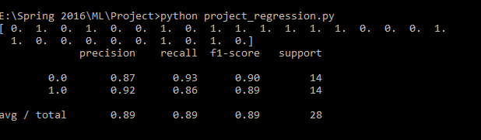

**From this result, we can see that the algorithm predicted with a precision of 89%.**